**Talk and Toss**

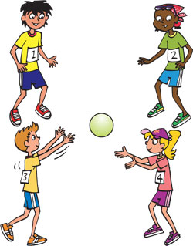

Play this game with your family to practice the art of conversation.

To play this game you will need a ball or balloon and at least two people.

1. Gather the players into a circle.
2. Get ready to start a conversation. You could ask a question or make a statement. Some good conversation starters are:
   1. My favorite sport is...
   2. I don’t like green beans (or pizza, or cotton candy) because...
   3. Have you ever climbed a tree?
   4. The most interesting animal I ever saw was...
   5. Remember when we...
3. The player who starts the conversation says his or her statement or question, then tosses the ball to any other player.
4. The player with the ball must think fast to continue the conversation! He or she should remember to ASK, SHARE, and LISTEN.
5. Then the second player tosses the ball to any other player, who must ASK or SHARE, and LISTEN, to continue the conversation.
6. If a player can’t continue the conversation, s/he must sit down.
7. Last two players standing win! They have mastered the art of conversation!
8. Make the game harder by counting down from 10 to 1 each time a new player catches the ball. The player must ASK or SHARE, and LISTEN before running out of time or that player is out.